

FACULTY OF INFORMATICS & DESIGN

Department | INFORMATION TECHNOLOGY
Qualification | ADVANCED DIPLOMA IN INFORMATION TECHNOLOGY
Qualification Duration | 1 year (Full-Time), 2 years (Part-Time)
Subject Code | APT470S
Subject Name | Application Development Theory 4
NQF Level | 7
SAQA Credits | 20
Pre-requisites | Application Development Theory 3 OR Equivalent

Class Exercise: Individual Work

Group: 1
Name: Thabiso Matsaba
Student Number: 22029606
Lecturer: Prof A. Ajibesin
Due Date: 16 April 2026

Question 1: UML State Machine Diagram – Smart Washing Machine [20 Marks]

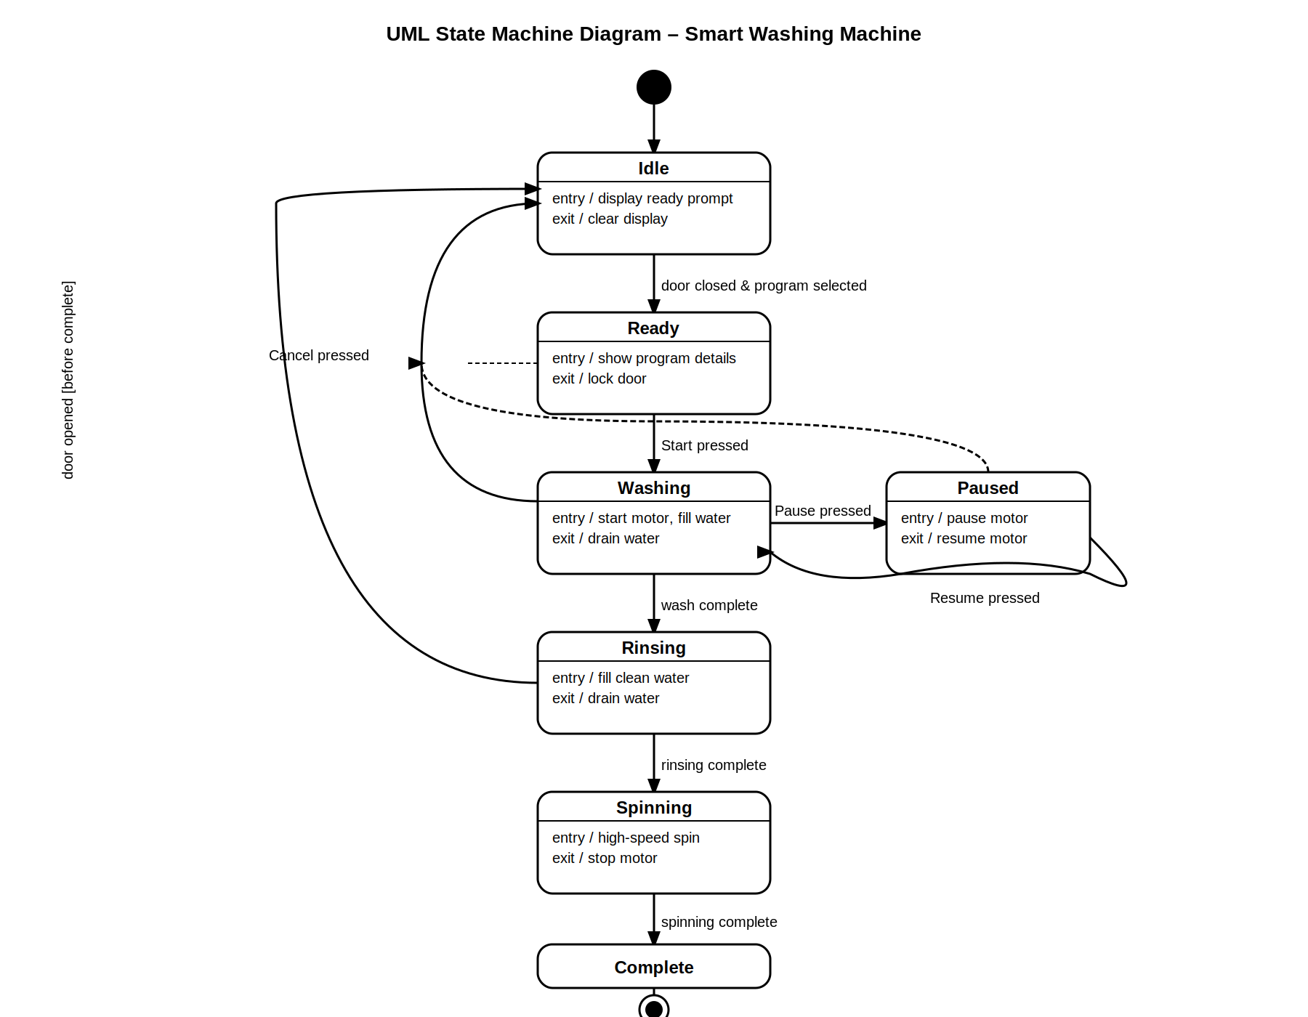

Figure 1: UML State Machine Diagram for the Smart Washing Machine

State Descriptions:
Idle: The initial state. The machine waits for user interaction. Entry action displays a ready prompt; exit action clears the display.
Ready: The door is closed and a wash program has been selected. Entry action shows program details; exit action locks the door.
Washing: Active washing cycle. Entry action starts the motor and fills water; exit action drains water.
Paused: The washing cycle is temporarily halted. Entry action pauses the motor; exit action resumes it on return.
Rinsing: The machine fills with clean water for rinsing. Entry action fills clean water; exit action drains.
Spinning: High-speed spin to extract water. Entry action activates high-speed spin; exit action stops the motor.
Complete: The full wash cycle has finished. The machine returns to idle after completion.

Global Transition: If the door is opened at any time before the Complete state, the machine transitions immediately back to Idle.
Question 2: UML Sequence Diagram – Student Grade Data Transfer [30 Marks]

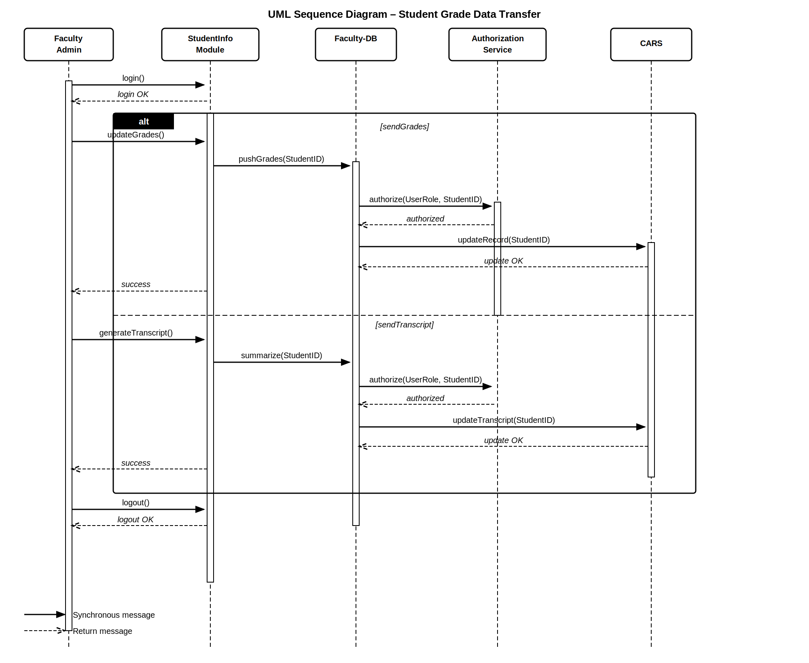

Figure 2: UML Sequence Diagram for Student Grade Data Transfer (CARS)

Diagram Description:
The Faculty Admin initiates the process by logging in. An alt fragment captures two alternative paths:
[sendGrades]: The Admin triggers updateGrades() on the StudentInfo Module, which calls pushGrades(StudentID) to the Faculty-DB. The Faculty-DB requests authorization via authorize(UserRole, StudentID) from the Authorization Service. Once authorized, Faculty-DB sends updateRecord(StudentID) to CARS. CARS returns update OK, and a success message is relayed back to the Faculty Admin.
[sendTranscript]: The Admin triggers generateTranscript() on the StudentInfo Module, which calls summarize(StudentID) to the Faculty-DB. Authorization is checked in the same manner. Faculty-DB sends updateTranscript(StudentID) to CARS. CARS returns update OK, and a success message is returned to the Faculty Admin.
After both paths, the Faculty Admin logs out of the system.

